BRAC UNIVERSITY
Department of Computer Science and Engineering

Examination: Final Exam  Duration: 1 Hour 15 Minutes | Semester: Spring 2024  Full Marks: 30
CSE 221: Algorithms

Answer the following questions.
Figures in the right margin indicate marks.

Name: | ID: | Section:

1 | CO1  CO1  CO1 | Professor Bumstead needs to figure out a proper order of clothing when getting dressed. He notes down some of the dependencies which describe which garments he needs to put on before others. For example, Prof Bumstead needs to put on his shirt before he puts on his tie or his belt. He wrote down the following:  - undershorts, watch and socks are independent  - pants need to be put on after undershorts  - shoes need to be put on after pants, undershorts and socks  - belt needs to be put on after pants and shirt  - tie needs to be put on after shirt  - jacket needs to be put on after tie and belt  - Write down the name of an appropriate algorithm to find the proper order of clothing items.  - Simulate the algorithm by drawing a proper graph and determining the correct order of clothing items. If you can choose among multiple items, choose the alphabetically smallest one. For example, between “shirt” and “shoes”, i comes before o, so choose “shirt”.  - Based on the clothing dependencies provided by Professor Bumstead, identify if there are any strongly connected components in the graph representation using an algorithm.  Demonstrate the steps of the algorithm you are applying or justify your answer in brief.  Solution: | 01  05  04
 |  | 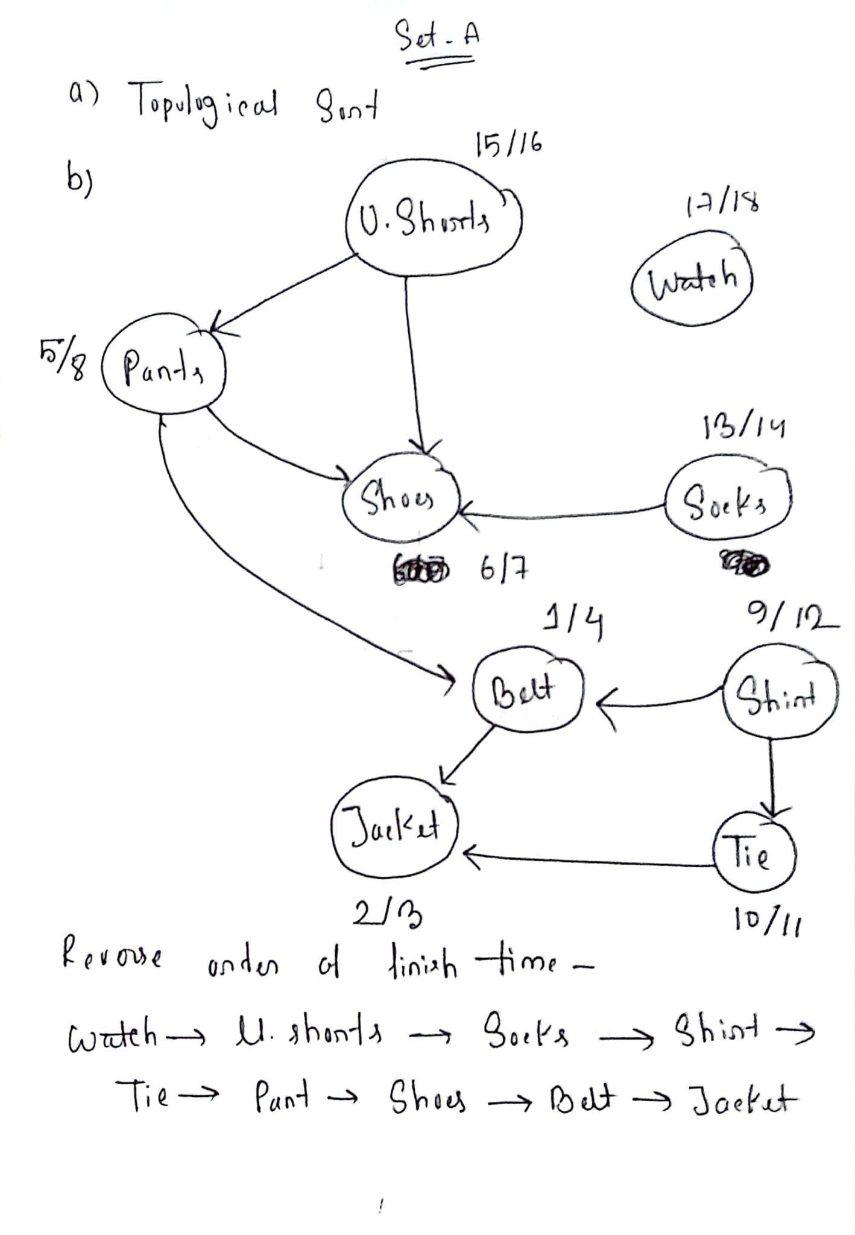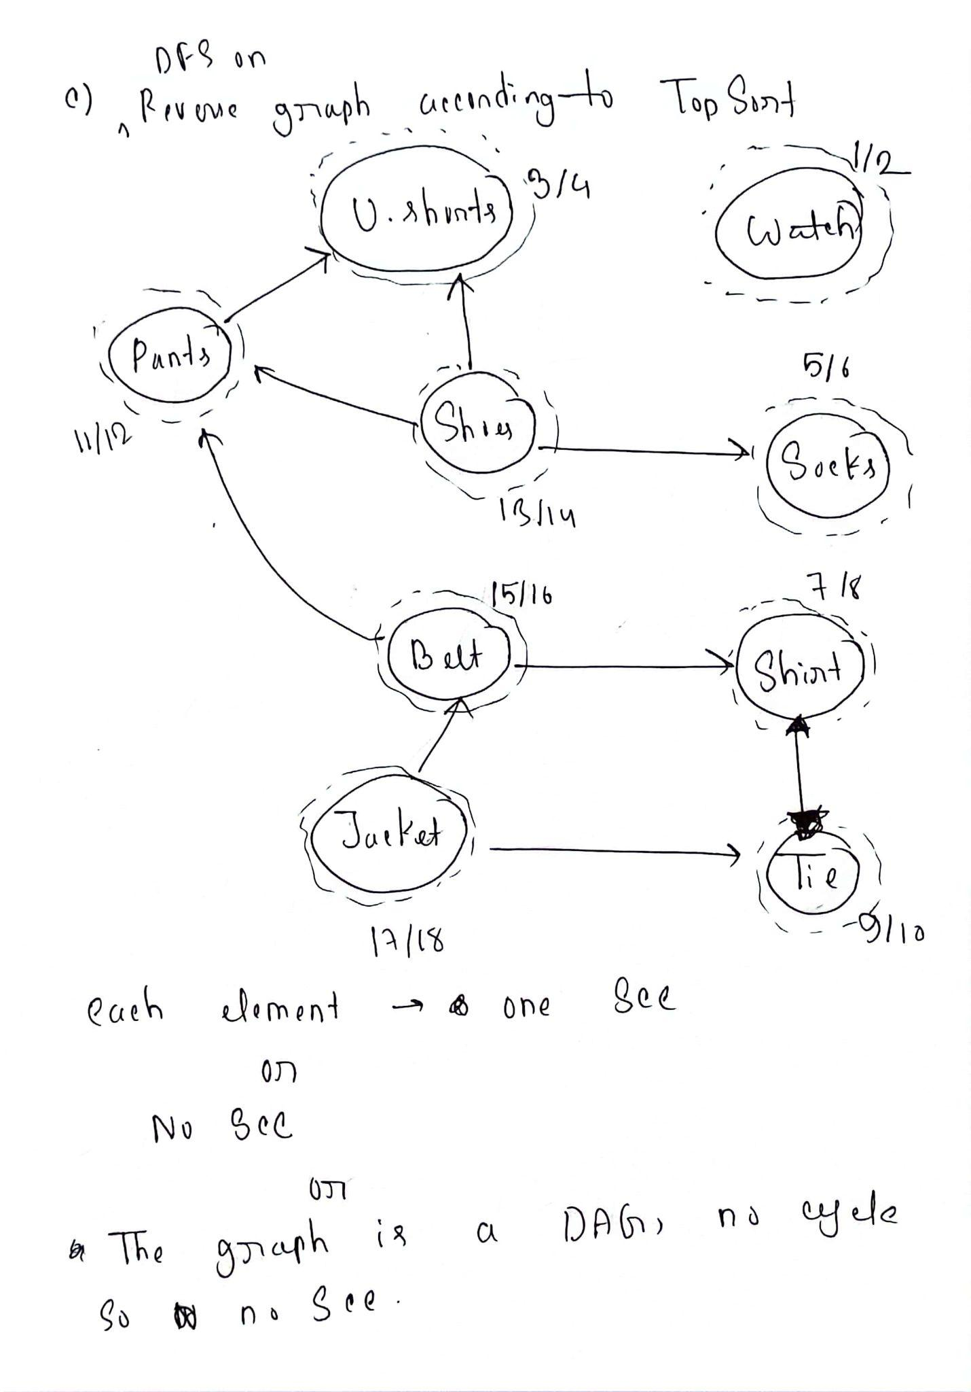
2 | a.  CO2 | You have this graph where there is a negative weight on one edge. Explain why Dijkstra’s shortest path algorithm will find correct answers on this graph given node A as the source. Then propose a change in the graph to make the result incorrect.  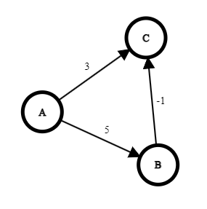  Solution : 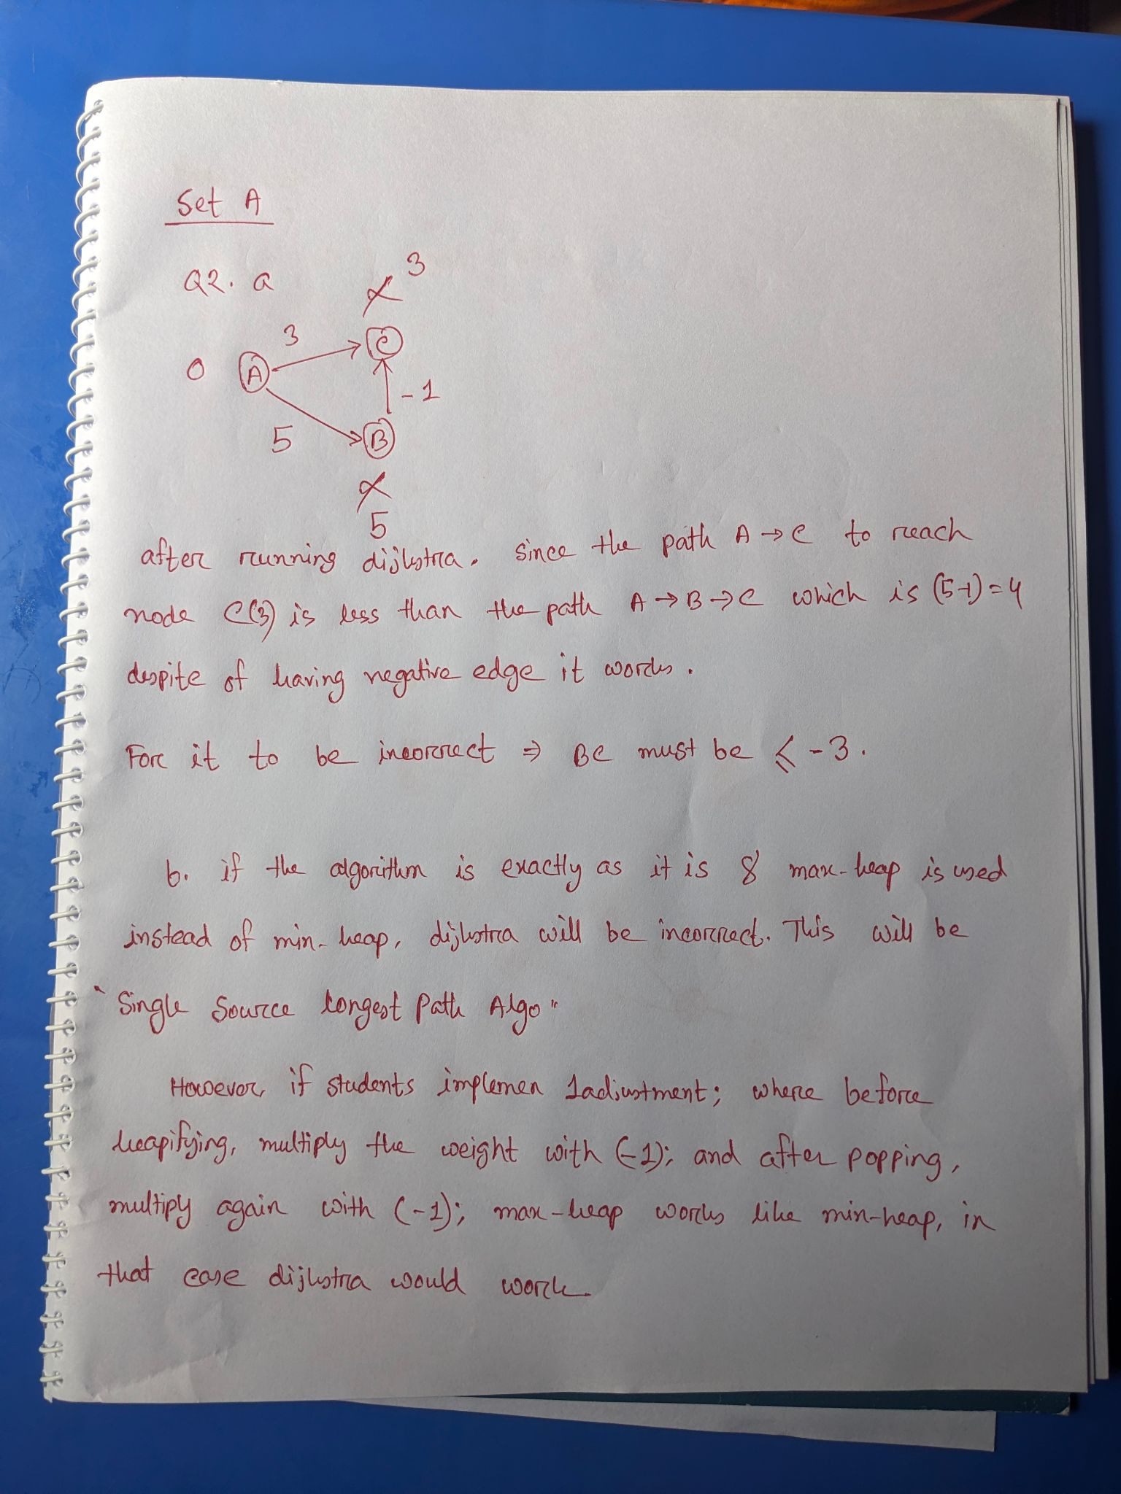 | 02
 | b.  CO2 | Someone mistakenly used Max-heap data structure instead of Min-heap to create a priority queue. So a pop/remove operation on the queue brings out the highest value element instead of the lowest one. Then this priority queue was used to implement Dijkstra’s algorithm.  Should it still work on any input graph? Explain your answer with proper reasoning and/or example. Assume that there will be no negative edges in the input.  Solution:  No, it won’t work. The vertex with the longest distance in the queue will be popped. And also, Dijkstra assumes that when a vertex is popped from the queue, its distance is final. So the implementation will ignore further updates to its distance. | 03
 | c.  CO1 | Construct the minimum spanning tree from the graph below. Present your work with proper details/data structures. Finally, draw the MST and write the total cost of that tree.  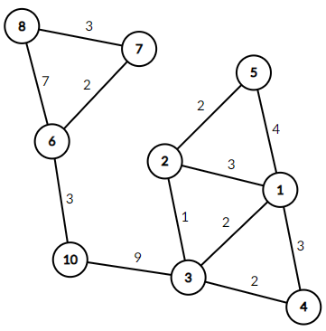 | 05
Ssolution :
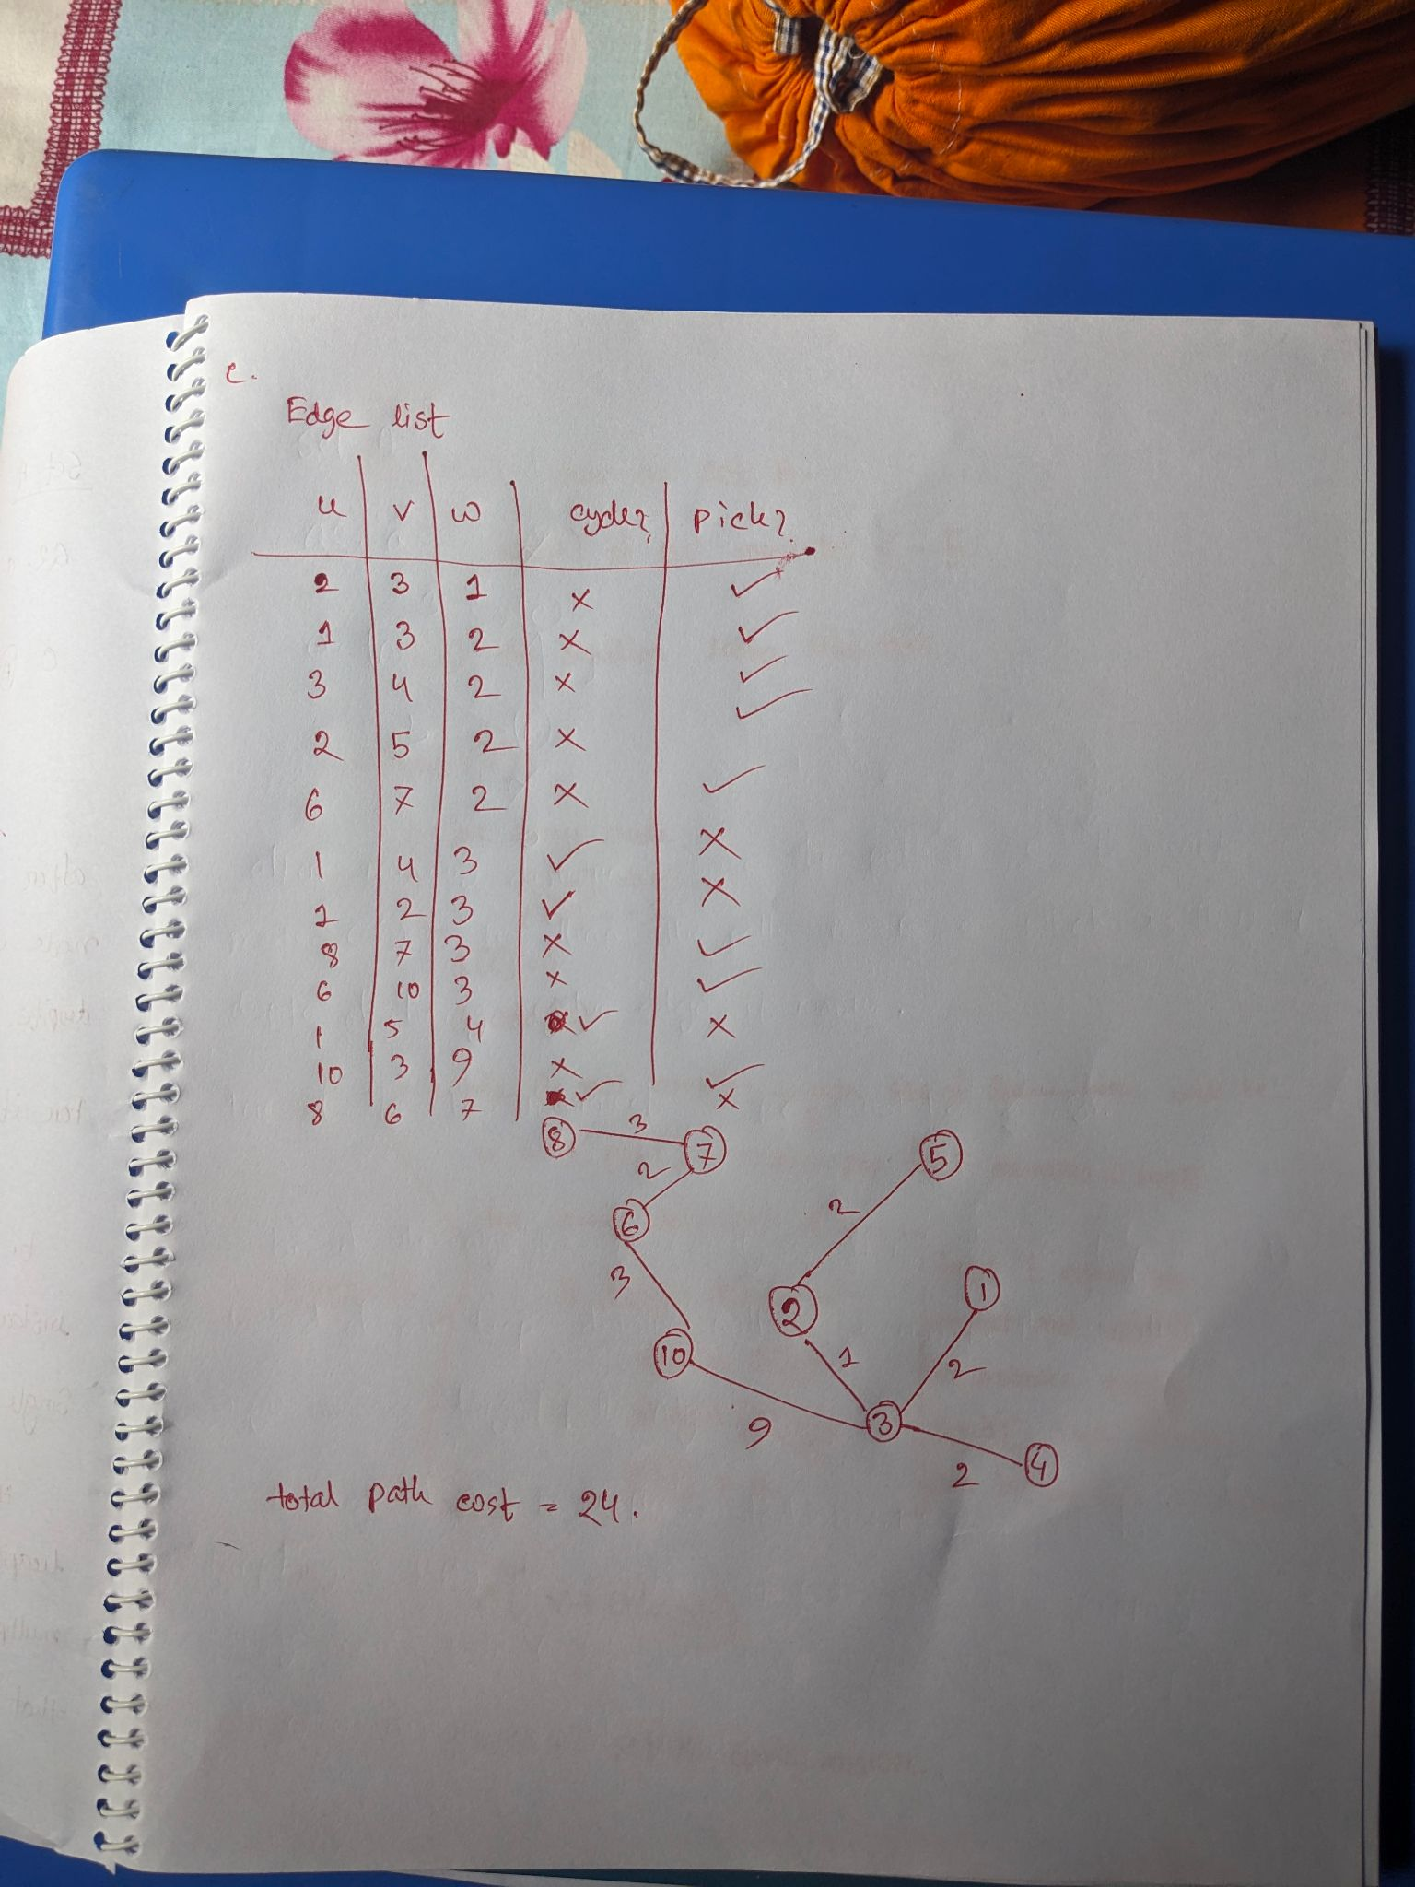
3 | CO1  CO1  CO1 | Wye is a CSE BracU Student. The pre-advising week is approaching, and he is trying to find the most suitable course combination for next semester. As per his previous academic results, his credit limit has been set to 9. Different courses have different credits. He came up with values for these courses by consulting with students who have already taken them. He wants to select the most valued courses. Courses, credits and values are provided below:  Course PHY112 CSE330 CSE331 CSE370 CSE499  Credit 1 2 3 4 5  Value 9 7 15 12 16  - Wye wants to try all possible combinations to find the best one. Help him by simulating a suitable dynamic programming approach. Show your work in detail, then write down the selected courses.  - Zed, a friend of Wye, adopted a slightly different approach and considered the courses based on their per-credit value. Determine whether Zed could select more valued courses than Wye.  Note that, selecting a course still means taking the whole, with full credits.  - If Zed is successful, he will send a message Successful; otherwise, Unsuccessful. Instead of fixed-length coding, he is willing to send the message using Huffman Coding. Show simulation of Huffman coding to encode his message.  Solution:  3a.  0 1 2 3 4 5 6 7 8 9  0 0 0 0 0 0 0 0 0 0  PHY112 0 9 9 9 9 9 9 9 9 9  CSE330 0 9 9 16 16 16 16 16 16 16  CSE331 0 9 9 16 24 24 31 31 31 31  CSE370 0 9 9 16 24 24 31 31 36 36  CSE499 0 9 9 16 24 24 31 31 36 40  Selected Courses : PHY112, CSE331 and CSE499  3b.  Course PHY112 CSE330 CSE331 CSE370 CSE499  Credit 1 2 3 4 5  Value 9 7 15 12 16  Per Credit Value 9/1=9 7/2=3.5 15/3=5 12/4=3 16/5=3.2  Credit Remaining Course Taken Course Credit Course Value  9 PHY112 1 9  8 CSE331 3 15  5 CSE330 2 7  3 No more courses can be taken. CSE370 is a 4 credits course and CSE449 IS a 5 credits course.  Total Value 9+15+7=31  No, Zed could not select more valued courses than Wye.  3c.  He will send Unsuccessful.  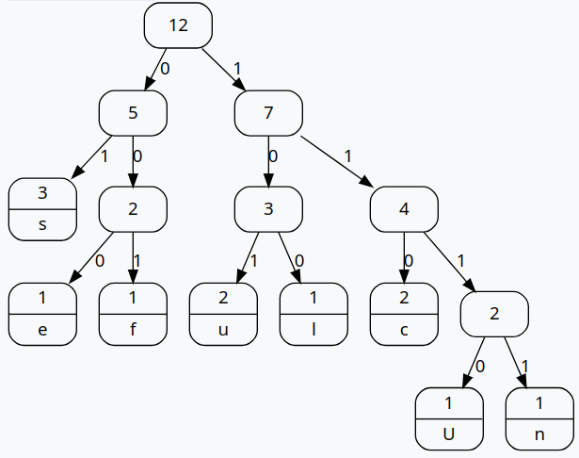  Codewords :  s - 01 e - 000 f - 001 u-101  l-100 c-110 U-1110 n-1111  Encoded Message :  11101111011011101100000101001101100 | 04  02  04

BRAC UNIVERSITY
Department of Computer Science and Engineering

Examination: Final Exam  Duration: 1 Hour 15 Minutes | Semester: Spring 2024  Full Marks: 30
CSE 221: Algorithms

Answer the following questions.
Figures in the right margin indicate marks.

Name: | ID: | Section:

1 | CO1  CO1  CO1 | Mr. Smith, a carpenter, needs to figure out a proper order of assembling items when making a bookshelf. He notes down some of the dependencies which describe which task he needs to complete before others. For example, he needs to create the frame before attaching the shelves. He wrote down the following:  - Frame, Paint and Shelf-stand are independent  - Back-panel needs to be installed after Frame  - Drawer needs to be installed after Paint, Back-Panel and Shelves  - Shelves need to be installed after Back-panel  - Screws need to be installed after Shelves and Back-panel  - Books need to be installed after Drawers  - Knobs need to be installed after Drawers  - Write down the name of an appropriate algorithm to find the proper order of tasks.  - Simulate the algorithm by drawing a proper graph and determining the correct order of tasks. If you can choose among multiple items, choose the alphabetically smallest one. For example, between “screws” and “shelves”, c comes before h, so choose “screws”.  - Based on the dependencies provided by Mr. Smith, identify if there are any strongly connected components in the graph representation using an algorithm.  Demonstrate the steps of the algorithm you are applying or justify your answer in brief. | 01  05  04
 |  | 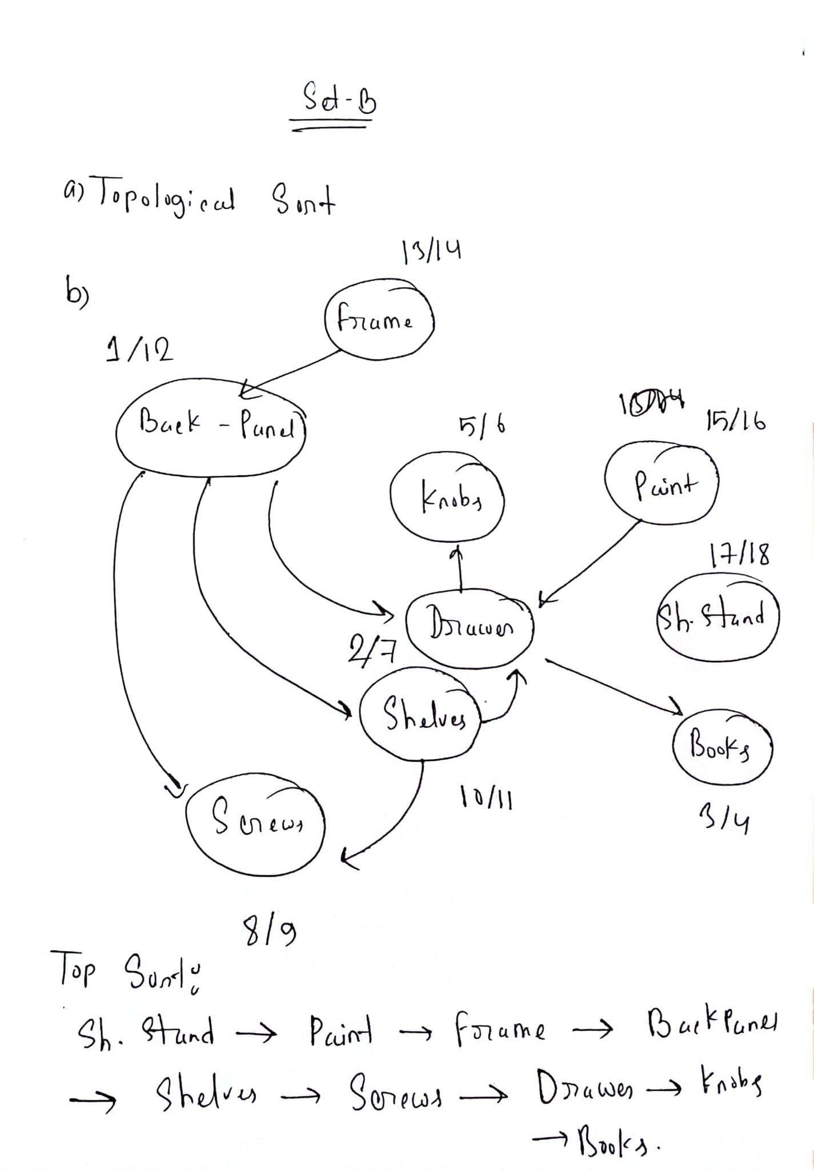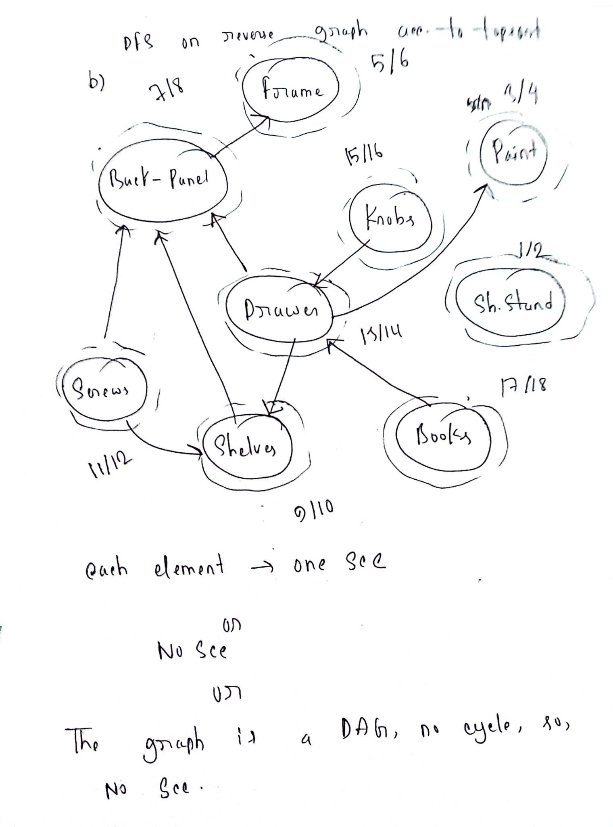
2 | a.  CO2 | You have this graph where there is a negative weight on one edge. Explain why Dijkstra’s shortest path algorithm will find correct answers on this graph given node A as the source. Then propose a change in the graph to make the result incorrect.  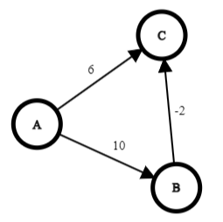  Solution : 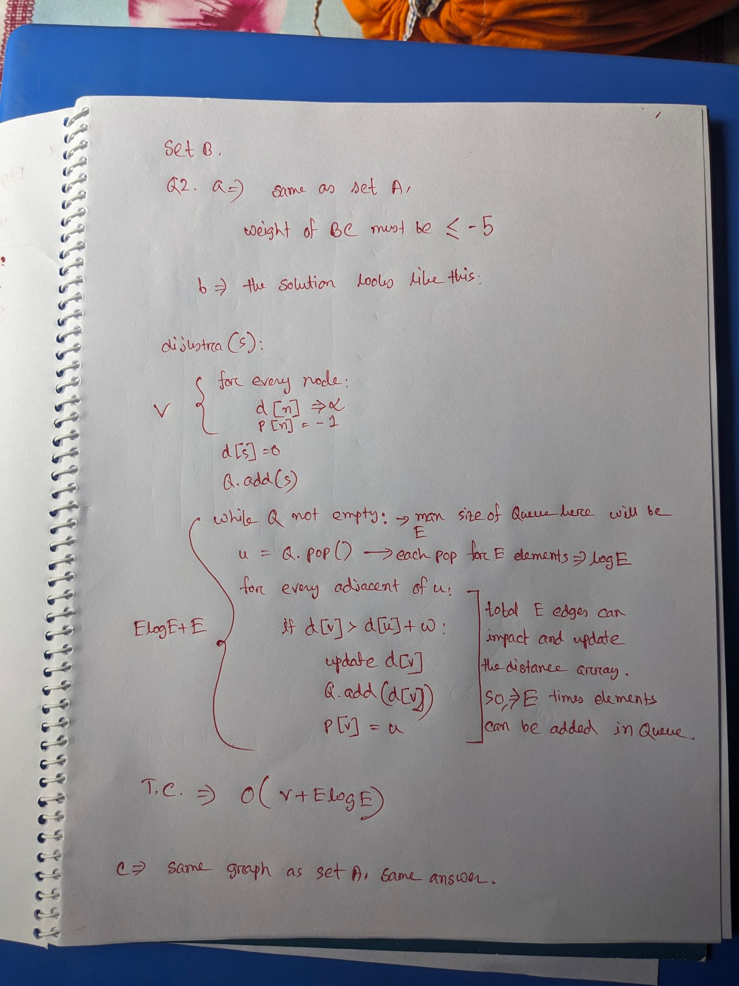 | 02
 | b.  CO2 | Dijkstra’s algorithm inserts all vertices in a priority queue/Min-heap at the beginning and then repeatedly extracts the vertex with minimum distance. However, someone proposed the following changes:  - At the beginning, it inserts only the source vertex in the priority queue.  - Whenever the distance of a vertex is updated, it then inserts that vertex into the queue.  Should the time complexity of the algorithm be same as before? Explain your answer with proper reasoning and/or example. Assume that there will be no negative edges in the input.  Solution:  No, complexity will increase. A vertex can get multiple distance updates, which means multiple entries in the queue. Even though those entries can be ignored or won’t be of any use (just the one for shortest distance will be needed), they will increase the number of loop iterations. | 03
 | c.  CO1 | Construct the minimum spanning tree from the graph below. Present your work with proper details/data structures. Finally, draw the MST and write the total cost of that tree.  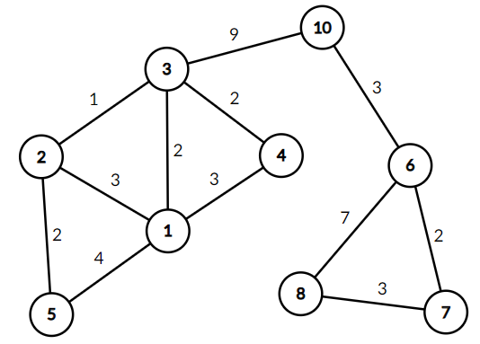 | 05
3 | CO1  CO1  CO1 | Wye is a CSE BracU Student. The pre-advising week is approaching, and he is trying to find the most suitable course combination for next semester. As per his previous academic results, his credit limit has been set to 9. Different courses have different credits. He came up with values for these courses by consulting with students who have already taken them. He wants to select the most valued courses.  Courses, credits and values are provided below:  Course PHY112 CSE330 CSE331 CSE370 CSE499  Credit 1 2 3 4 5  Value 10 8 16 13 17  - Wye wants to try all possible combinations to find the best one. Help him by simulating a suitable dynamic programming approach. Show your work in detail, then write down the selected courses.  - Zed, a friend of Wye, adopted a slightly different approach and considered the courses based on their per-credit value. Determine whether Zed could select more valued courses than Wye.  Note that, selecting a course still means taking the whole, with full credits.  - If Zed is successful, he will send a message Successful; otherwise, Unsuccessful. Instead of fixed-length coding, he is willing to send the message using Huffman Coding. Show simulation of Huffman coding to encode his message.  Solution :  3a.  0 1 2 3 4 5 6 7 8 9  0 0 0 0 0 0 0 0 0 0  PHY112 0 10 10 10 10 10 10 10 10 10  CSE330 0 10 10 18 18 18 18 18 18 18  CSE331 0 10 10 18 26 26 34 34 34 34  CSE370 0 10 10 18 26 26 34 34 39 39  CSE499 0 10 10 18 26 26 34 34 39 43  Selected Courses : PHY112, CSE331 and CSE499  3b.  Course PHY112 CSE330 CSE331 CSE370 CSE499  Credit 1 2 3 4 5  Value 10 8 16 13 17  Per Credit Value 10/1=10 8/2=4 16/3=5.33 13/4=3.25 17/5=3.4  Credit Remaining Course Taken Course Credit Course Value  9 PHY112 1 10  8 CSE331 3 16  5 CSE330 2 8  3 No more courses can be taken. CSE370 is a 4 credits course and CSE449 IS a 5 credits course.  Total Value 10+16+8=34  No, Zed could not select more valued courses than Wye.  3c.  He will send Unsuccessful.    Codewords :  s - 01 e - 000 f - 001 u-101  l-100 c-110 U-1110 n-1111  Encoded Message :  11101111011011101100000101001101100 | 04  02  04

